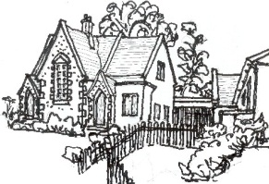
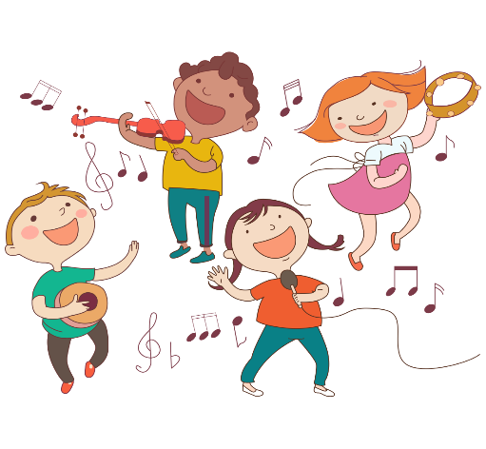
This Photo by Unknown Author is licensed under CC BY-SA-NC

An Early Years Musician
The table below outlines the most relevant statements taken from the Early Learning Goals in the EYFS statutory framework and the Development Matters age ranges for Three and Four-Year-Olds and Reception to match the programme of study for music.
The most relevant statements for music are taken from the following areas of learning:
- Communication and Language
- Physical Development
- Expressive Arts and Design

Age Range | Area of Learning |  | Skills
3 and 4 Year-Olds | Communication and Language |  | - Sing a large repertoire of songs.
 | Expressive Arts and Design |  | - Listen with increased attention to sounds.  - Respond to what they have heard, expressing their thoughts and feelings.  - Remember and sing entire songs.  - Sing the pitch of a tone sung by another person (‘pitch match’).  - Sing the melodic shape (moving melody, such as up and down, down and up) of familiar songs.  - Create their own songs or improvise a song around one they know.  - Play instruments with increasing control to express their feelings and ideas.
 | Physical Development |  | - Use large-muscle movements to wave flags and streamers, paint and make marks.
Reception | Communication and Language |  | - Listen carefully to rhymes and songs, paying attention to how they sound.  - Learn rhymes, poems and songs.
Reception | Expressive Arts and Design |  | - Explore, use and refine a variety of artistic effects to express their ideas and feelings.  - Return to and build on their previous learning, refining ideas and developing their ability to represent them.  - Create collaboratively sharing ideas, resources and skills.  - Listen attentively, move to and talk about music, expressing their feelings and responses.  - Sing in a group or on their own, increasingly matching the pitch and following the melody.  - Explore and engage in music making and dance, performing solo or in groups.
Reception | Physical Development |  | - Combine different movements with ease and fluency.
Early Learning Goal | Expressive Arts and Design | Being Imaginative and Expressive | - Sing a range of well-known nursery rhymes and songs.  - Perform songs, rhymes, poems and stories with others, and (when appropriate) try to move in time with music.

